A181-Asia-Indus Valley-Figurine-Standing Fertility Goddess-2800 BCE-2600 BCE

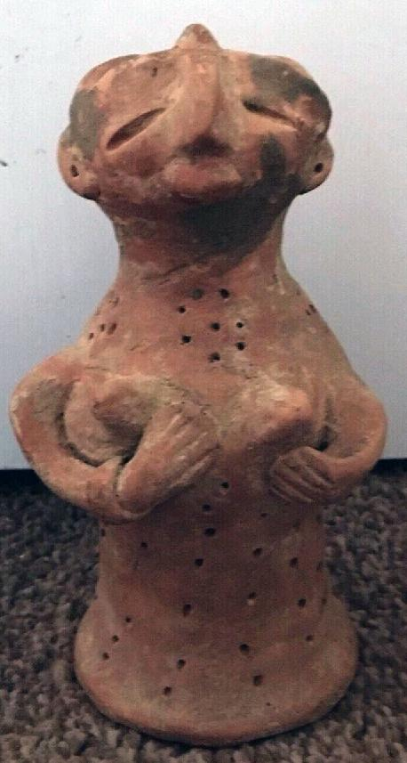 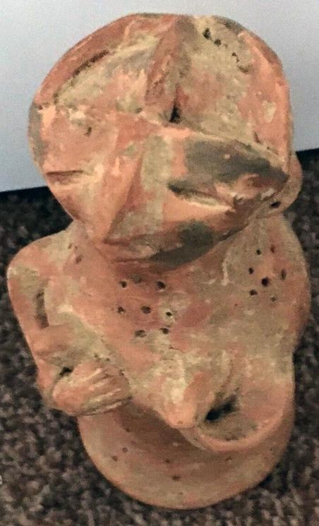 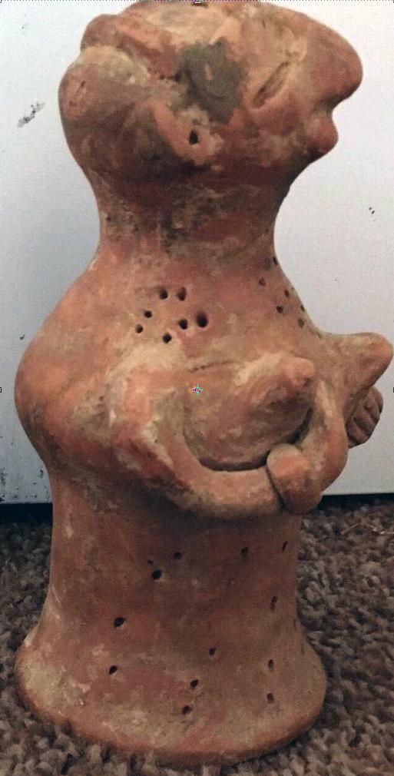

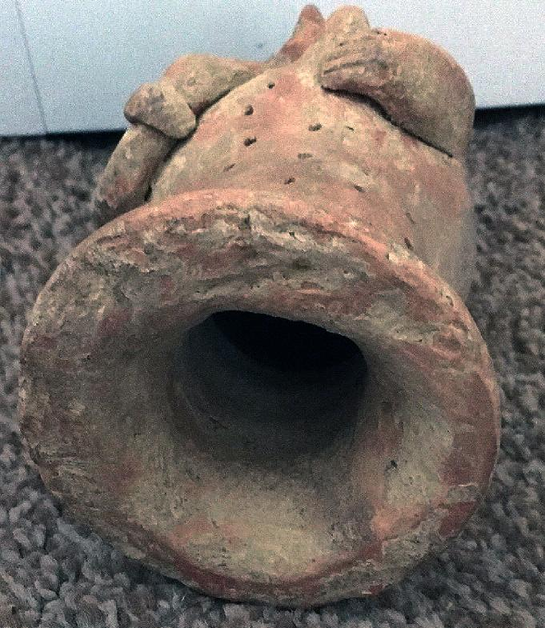

Figs. 1-4. Indus Valley-Figurine-Standing Fertility Goddess-2800 BCE-2600 BCE

Accession Number: A181

Case no.: 3

Formal Label: Indus Valley-Figurine-Standing Fertility Goddess-2800 BCE-2600 BCE

**Display Description:**

This female terracotta figurine, has been cast with two cranial spaces to insert elaborate headgear which was supported by bands. The two hands are placed against the breasts to indicate that the individual is lactating. The cylindrical body is perforated with holes that imply a fabric design of a tight-fitting dress. The cylinder is hollow with an everted base.

A female figure such as this one, being made of terracotta, materially originates with the Earth and has been identified as a Mother Goddess by most scholars. This figure embodies three aspects that are not mutually exclusive. First, it may be a votive image of a human birth-giving mother (perhaps as a specific votary object to assist the women of a family in their birth-giving rôles). Secondly, it may be a general archetypal symbol for harvested crops or yields of animal husbandry, both products of Earth. An association with animals may allude to an ability to command animals as the queen beasts, tame and wild. Thirdly, it may be the object of a fertility cult, specifically focused on the need to supply a family with children and then later with young adults, who could help manage the family’s farming and herding. As an element of the family’s security, this archetypal rôle is practiced by one billion women in the developing world today.

Cultural Affiliation: Indus

Medium: terracotta

Dimensions: H 20 cm x Dia 9 cm

Weight: 587g, 1 lb 4.5 oz

Condition: original

Provenance: part of an old collection

**Discussion:**

An archetypal mother in Indus civilization appears to be projected as a local female divinity. The cult of local female-worship, coupled with a fertility cult, seems to have been deep-rooted and wide-spread in Neolithic India, since female figurines have been recovered from nearly every excavated site. This pervasiveness suggests that women played a central rôle in their *family’s* *local economy* and *religion* and that the society that supported such a rôle for women was *locally egalitarian*.

However, this localism existed in tandem with a non-local, male-dominated administration of centralized city-states. This included fairly extensive town-planning, maintenance of weights and measures and the production of a variety of unique stamp seals that were ostensibly part of the business identification of a wealthy, male merchant class that engaged in extensive trading throughout the subcontinent and the Near East.

**References:**

Atre, Shughangana. 1987. *The Archetypal Mother: A Systematic Approach to Harappan Religion*. Pune: Ravish Publishers.

Bailey, Donald M. 1997. “Terracotta Figurines of Eastern Gujarat”. In Ian Freestone and David Gamester, eds., *Pottery in the Making: Ceramic Traditions*. Washington, D.C.: Smithsonian Institution Press.

Bhattacharyya, N. N. 1999. *The Indian Mother Goddess*. New Delhi: Manohar.

**AP:** 6.5, Barakat Gallery: London

Order details

## Sales order

Sold by [danny1970000](http://myworld.ebay.com/danny1970000) ( [880](http://feedback.ebay.com/ws/eBayISAPI.dll?ViewFeedback&userid=danny1970000) )

Estimated delivery Friday, Dec 16, 2016 - Thursday, Jan 5, 2017

#### [VERY Rare MUSEUM QUALITY INDUS VALLEY TERRACOTTA Mother Goddess](http://www.ebay.com/itm/262745624202)

|  |  |
| --- | --- |
| Item price | $127.05 |
| Quantity | 1 |
| Item number | 262745624202 |
| Shipping service | Royal Mail International Signed |